|  |
| --- |
| Software Engineering of Distributed Systems, KTH |
| Distributed Systems Advanced Homework 2 |
| Implementation of Perfect Failure Detector Component and Eventually Perfect Failure Detector Component |

|  |
| --- |
| Shanbo Li and Sike Huang  2/9/2008 |

# Exercise 1: Verify the completeness of the failure detectors

The topology is shown as following, three nodes are connected together, and each node has two links to the other two nodes respectively.

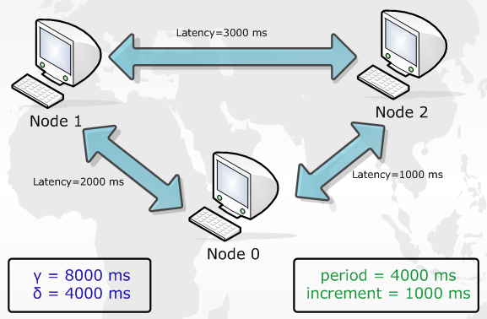

## 1.1 Experiment with Perfect Failure Detector Component

After system starts, every node works well. Each of them can receive heartbeat from others.

We manually crash node 2 and the follows are the output of node 1 and node 0:

|  |
| --- |
| Node 1: |
| Failure detected! Node 2 crash!  At 1202571122483  Duration since last heartbeat is 26031 ms  Gamma = 8000 ms  Delta = 4000 ms |

|  |
| --- |
| Node 0: |
| Failure detected! Node 2 crash!  At 1202571120311  Duration since last heartbeat is 23859  Gamma = 8000  Delta = 4000 |